Acne

***You don’t need to be worried about acne!***

What is Acne?

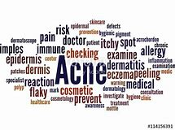The scientific name of acne is acne vulgaris. These are red spots that occur when a hormone is released and that comes with puberty. But how do hormones effect acne?

Well, the sex hormones in women and men change from androgen to oestrogen. If the oestrogen levels change, the oil glands will release more. This process causes acne.

If you get this, it could appear usually on your face, or you upper back, chest, neck or shoulders. If you don’t treat you acne, it could stay around for 3-5 years!

Things to Help

Here are a list of things that can help stop acne:

You could:

Wash your face oncwe or twice a day.

(But make sure you wash your hands before your face for good results)

You could get acne soap to use whilst cleaning yourself

(This will take the moisture and oils out of your skin)

If you have long hair, try keep your hair off your face.

(Your scalp releases natural oils to keep your hair shiny and can cause acne)

If you wear makeup, try to avoid doing it so often.

Gels, mouses and sprays can get into the pores of your skin and create pimples

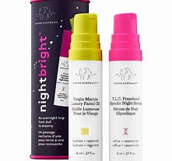Product

One product I recommend is Drunk Elephant nightbright. This helps your skin and reduces the amount of acne and how long it stays.

This product has scientfically helped people with acne. Many reviews say that no other product had actually helped except for this. Of course it may take a while, but this product makes you feel better about yourself and will make you want to go out and see you friends and meet up with them.

Social Life

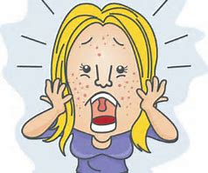Acne can effect someone’s social life; depending on who you are though. It coould make you feel more self-conscious. This could conclude you to not want to go out and meet up with your friends. One story is that a young girl called Abbie, preffered going to parties when it was dark so no one can see her face.

Sources:

<https://www.learnreligions.com/natural-solutions-for-acne-1725688>

<https://www.epainassist.com/skin/acne/how-and-why-do-hormones-cause-acne>

https://www.influenster.com/reviews/drunk-elephant-nightbrighttm

<https://www.bupa.co.uk/health-information/healthy-skin/acne>