  https://www.accomnews.com.au/2017/05/social-media-success-for-your-hotel/  - There are lots of different apps which will allow you to text, send photos and videos. Make sure you are not doing the wrong things on them!  Cyber Bullying  Cyber Bullying is when someone is bullying someone else online and the other person does not like it so they can click the report abuse button and something will be done about it. Always tell an adult if anything is happening to you online. This is to keep you safe! | What E-Safety Means?  E-Safety means to keep safe whilst you are online and also being aware of what you are doing with other people and making sure that you definitely know them.  Social Media  When you are on social media you always need to make sure, what you are posting, who you are posting it to and who is following you. A good way to do this is to keep your account private which means that no one can follow you unless you accept their friend request  Passwords  When you are creating a password always, include Capital Letters, numbers and maybe even symbols. This is to prevent hackers to guess your passcodes easily and quickly. | E-Safety  - Keeping safe in the online world.  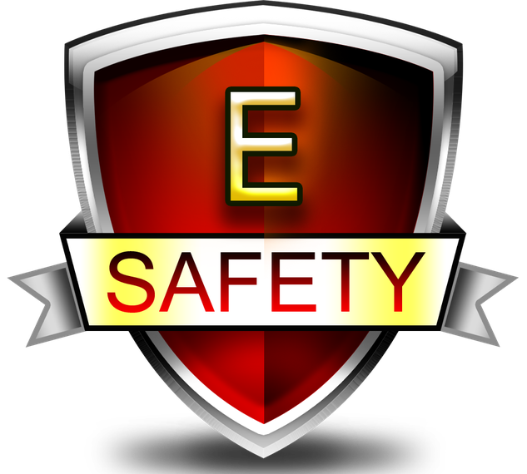
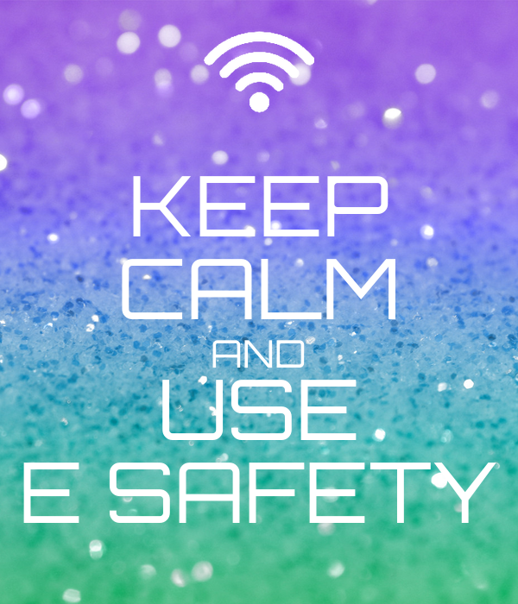  Report Abuse  This is the button which will stop whatever is worrying you on social media. You can click this anytime. Never be frightened to click this as you be threatened by someone not to do it.  Stranger Danger  When you are online, never make friends with people you don’t know. They could be faking their identity. If you do become friends with someone online, always ask a trusted adult to come with you if anything happens. |   Keeping Safe on Social Media  As we are becoming older, more and more social media is being used daily. We still need to be aware about what we are doing, sexting and just general chats.  There are many of keeping safe o Social Media such as turning your account on to private, only communicate with people you know or trust, keep some things private to yourself if it is not sensible. |   Viruses  A computer virus is a program that when it runs, it copies itself. To protect yourself from computer viruses, you may want to install an anti-virus software which detects whether you have a virus or not and tries to stop it from happening.  Phishing  Phishing is when someone sends you an email and they are trying to get personal information out of someone such as passwords, credit card numbers and even your D.O.B. If you receive an email from someone you don’t know, don’t open it as they may be trying to influence you to give away personal information to them and after that, they can do whatever they like with it and without your permission.

