Investigating the effect of Tilt on Photovoltaic cell

Hypothesis:

To find out how the tilt affects the potential difference on photovoltaic cell, I am going to measure using a Voltmeter, the potential difference at each angle using a protractor. I believe that the less direct the sun is to the photovoltaic cell, the less the ammeter reading will show. I think this because when the sun is directed it has the largest amount of surface area to collect the sunlight and convert into energy.

List of Apparatus:

* Small PV Cell
* DC Voltmeter – To measure the potential difference.
* Protractor – To measure the angle of the PV Cell.
* Source of bright light or access to direct sunlight – To make the PV Cell work
* Two electrical leads with alligator clips – To power the PV Cell to the Voltmeter

Method Investigation

1. To begin, you must prepare by getting all of the apparatus ready. Using the red and black cable attached to the PV cell, plug them into the colour coded sockets on the Voltmeter - Keep all water and liquids away to prevent electrical hazards.
2. Now that the PV cell is ready, we can prepare the light source. Get a lamp or a torch and carefully lay it on its side as you will be investigating the tilt of the PV Cell.
3. Choose a spot where you will be placing your PV Cell and measure 30cm away from that and place your lamp there. Your lamp may begin to get hot quite fast so touch it using the back arm or base to avoid burns.
4. Using your protractor, lay your PV cell at a 10° angle and measure the potential difference reading that your Voltmeter will say.
5. Next, you need to stand the PV cell up a little steeper and using your protractor, find it when it is at a 20° angle. Measure the reading and record the result. Repeat this process per 10° until you reach 90° and record the results for each one.
6. Do this step three times and put them into a table of results. Find out the average of each angle and this will give you your most accurate result possible. You can always increase the number of repeats to get an even more accurate result but 3 is good amount.
7. Pack up your equipment safely and responsibly, if anything is to break tell the teacher and if anything does spill quickly mop it up to prevent any accidents.
8. Using the average of each angle, produce a line graph and draw a line of best fit. Line of best fit is a line through a scatter plot of data points that best expresses the relationship between those points.

Dependent Variable: The Potential Difference

Independent Variable: The tilt of the Photovoltaic Cells

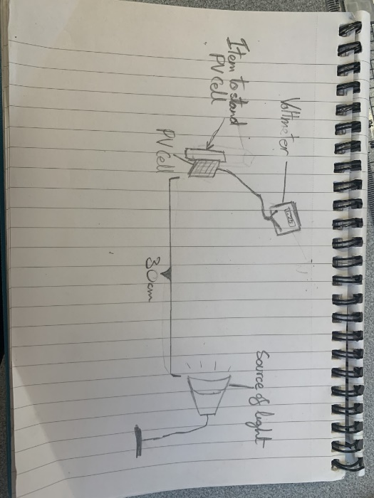Diagram of Experiment

Image During Experiment

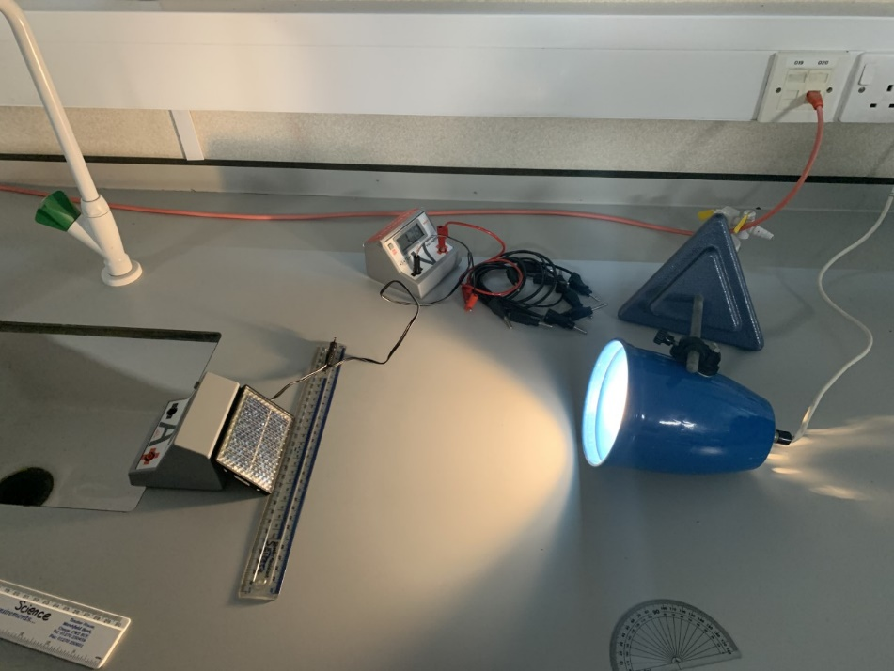

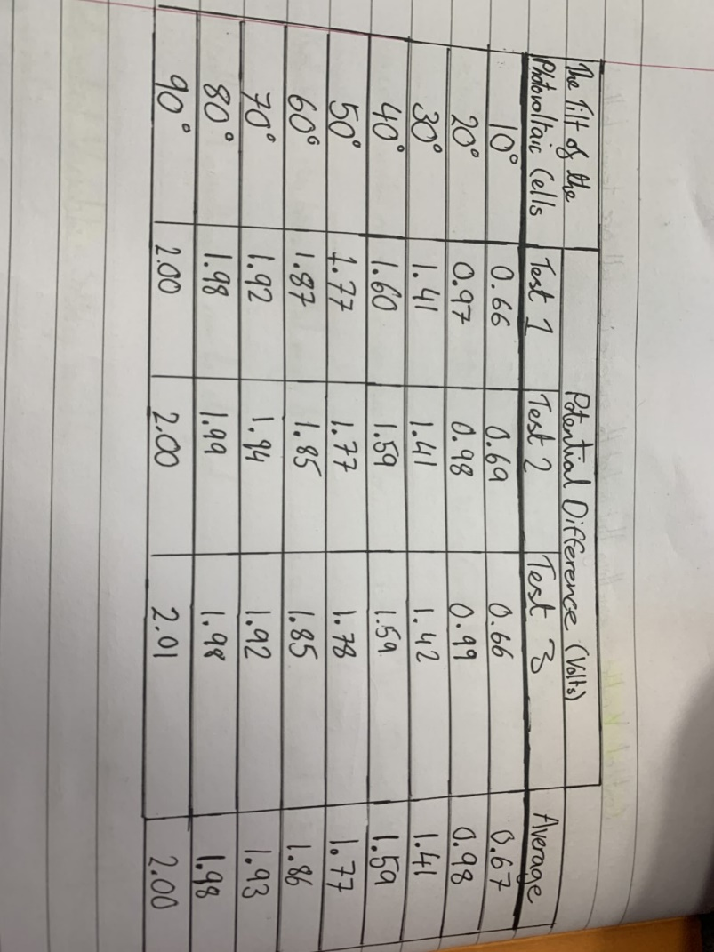

Table of Results

Line graph

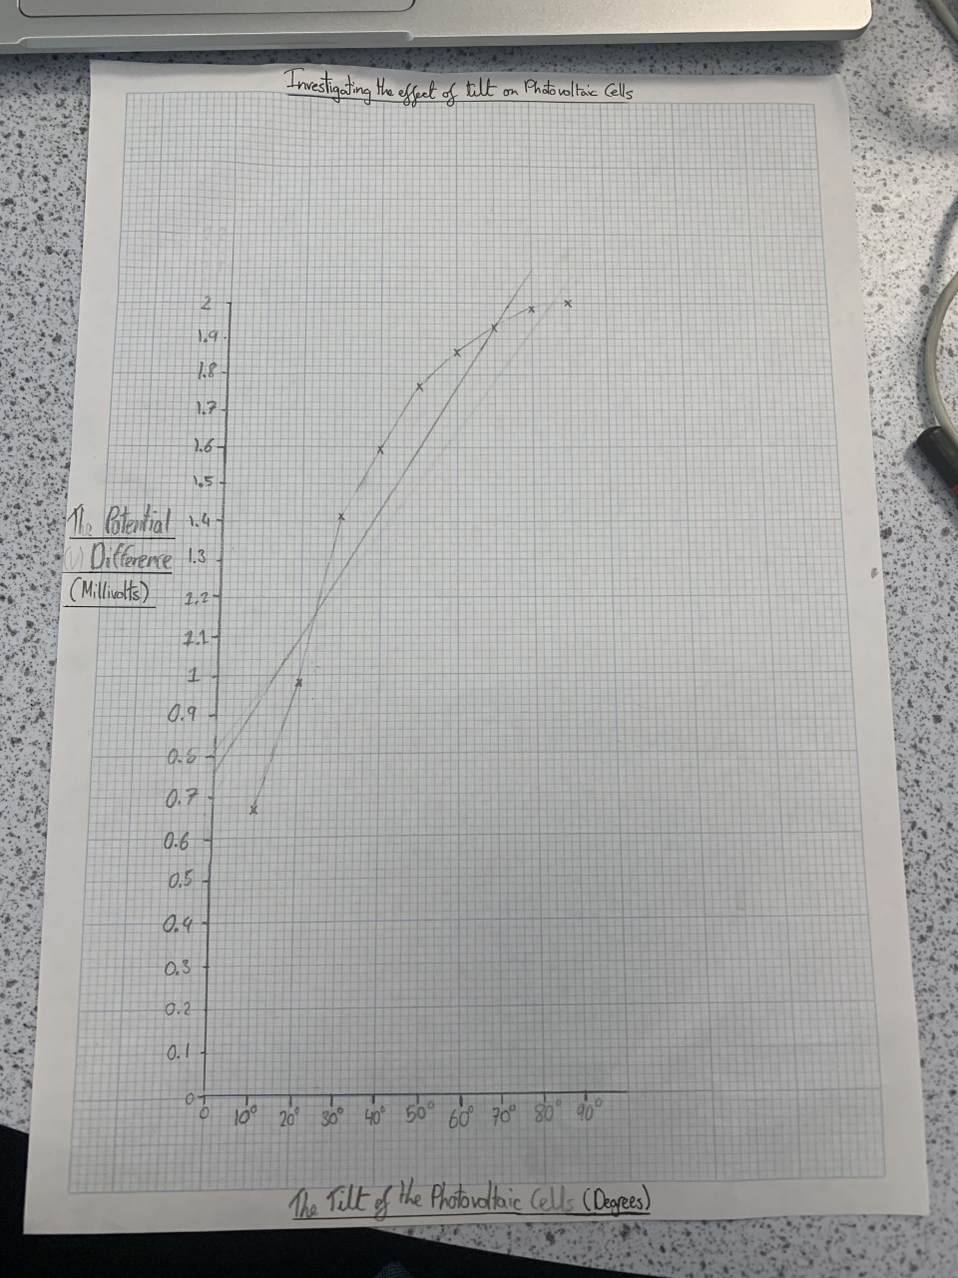

|  |  |  |
| --- | --- | --- |
| Control Variable | How will you control it? | What would happen if it changed? Be specific! |
| The distance between the light and the PV Cell. | We will measure the distance between them after each result | The distance would affect the amount of useful energy produced as when the light source it will make the PV Cells hotter creating more energy |
| The colour of the light | We will use our same source of light every time | Our reading on the Voltmeter would change and would give us a false result meaning the may be an anomaly in our results. |
| The brightness of the light | Keep the location of our source of light in the same location and keep the same distance. | This will create a false potential difference of volts produced as the heat will be more concentrated on the cells creating more energy. |
| Shading | Keeping the PV Cell away from any other objects which may be creating a shadow over the PV Cell | It will create a lower reading as it blocks the light from reaching the cells and creating energy; creating an anomaly in our results list. |

Safety and Risk Assessment:

* I need to keep any water away that could possibly spill as this experiment requires electrical equipment.
* I need to be wary of sharp fragile object and use them safely and responsibly to prevent any breakages or even worse being a safety risk to me and peers.
* Make sure not to touch any hot equipment such as the edge of the lamp shade as you could burn yourself.
* If there is to be a broken item on the floor or on the table, make sure to tell the teacher and block off the area to stop people from going near it and hurting themselves.

Conclusion:

Our experiment was to investigate the effect of tilt on a PV Cell; this was to find out how much energy is produced at each angle of the PV Cell. The results supported my hypothesis that the less direct the sun is to the photovoltaic cell, the less the ammeter reading will show. This can be seen in both the results and the graph as there is a positive correlation meaning both the Dependent and Independent Variable are increasing and decreasing together. 90 degrees created the largest amount of potential difference and 10 degrees created the least. I think the PV Cell was best when it was direct to the light source because solar energy is produced best when the PV Cell can absorb the most amount of sunlight possible. There weren’t any anomalies in our results meaning that they were fairly accurate.

Reflection/Evaluation:

I think the results were all fairly accurate as there were not any anomalies in the graph or results table. I made the experiment fair by turning off all nearby lights and shutting the curtains to avoid any extra sunlight making changing the results. Keeping our lamp, the same distance away throughout the experiment (30cm) was important as distance is also important when finding potential difference. My method was good as it was efficient and gave us very accurate results although what had taken us a long time was propping up the PV Cell at the correct angle and making sure it would not fall over mid experiment. Another experiment I could do in the future for an even more detailed investigation, could be completing a 180 degree turn and seeing if the graph would give a u-like shape. I could also complete the experiment in a completely dark room giving the most accurate result in terms of light possible.