Excel Quiz Report

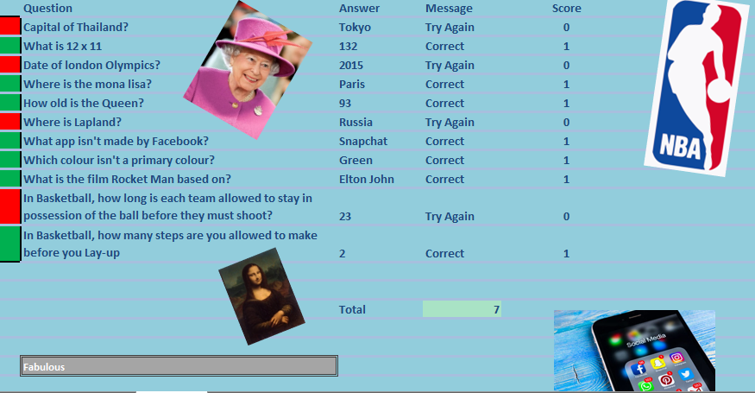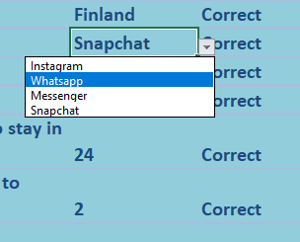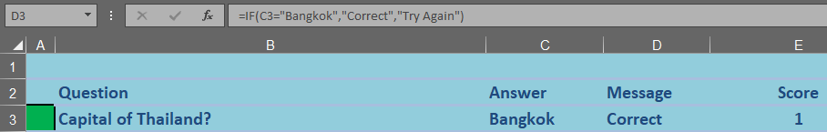

This is a drop-down box. I managed to do this by clicking on the data title and pressing ‘data validation’. I then clicked on ‘list’ as I was making a multiple-choice question and typed in the 4 different answers and pressed OK.

This is my completed Excel Quiz. I decided to include a range of questions including many different topics. Throughout this report I will explain what I did and how I did it (formulae).

This picture shows the formula in which it changes the message if the answer is right or wrong. In this case, the answer is right and that is why the message says ‘correct’. As you can see in the formula, if the answer was wrong, the message would say ‘Try Again’. This is called the **IF statement.**

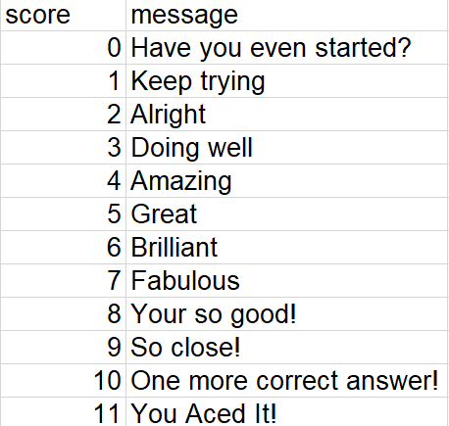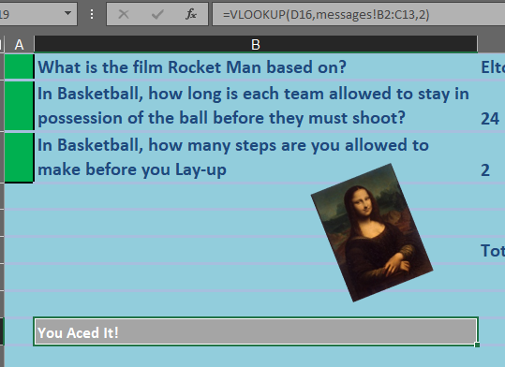

This picture is showing the **VLOOKUP.** This is where on another page I write messages and according to my score, the message changes. The photo on the left is showing how there are 11 different messages for whatever my score is. The photo on the right is on the quiz page and is showing the formula relating to the messages.

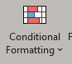



Conditional Formatting is a thing in which there is a colour code for if the answer is correct or wrong. This is really useful because it makes it really easy to see how well someone has done on each answer. To do this you have to click on the title – Home and then press on the button which you can see above. (Make sure you click on the cell you would like to format). Select the rule type you want, and choose the colour range, this will now format the cell.

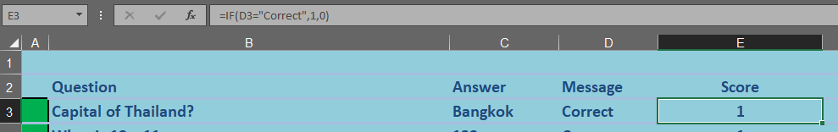

This is another form of the **IF Statement.** This one is basically like the other one but the only change is that this one checks the MESSAGE column and if it says correct, the score column will have a 1 inside it showing that 1 point is awarded for getting the question right. The same sort of thing would happen if the answer was wrong although the score column will just say 0.

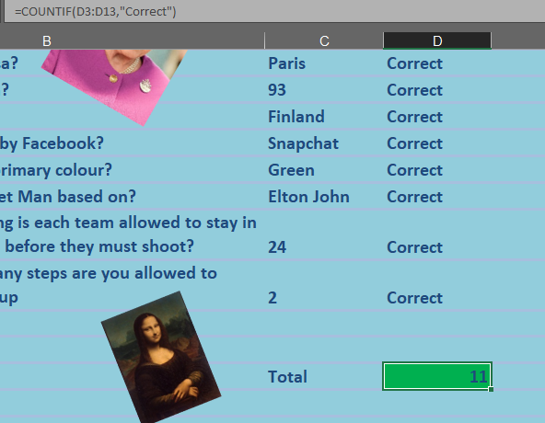

This picture is now showing the **COUNTIF STATEMENT.** This statement looks at all the cells in the column D that say correct and counts them up. The reason it is called that is because the IF statement telling the person whether their answer is correct or false and finally the count if statement simply counts up how many correct answers are by the questions. When you look at the names of them, you can easily understand why they are called that.

 

Finally, the last thing is cell protection, this feature helps stop people from editing your document whilst trying to complete the quiz. To do this, you have go into home, format and as the photo shows, click on protect sheet. Make sure you have highlighted the section you want to keep unprotected. Once you’ve clicked on it, there will be a list of what you want to protect. Tick only the one that says,0 ‘select unlocked cells.’ This will stop the user from editing your document.